Voronoi Everywhere

An Algorithmic Exploration of Architectural Texture

Module: Programming for Artists and Designers (Term 1)
Programme: MA Computational Arts
Institution: Goldsmiths, University of London

Author Information:
Sohyun Jun
33898184
sjun002@gold.ac.uk

Introduction
This report documents the initial phase and outcomes of the project ‘Voronoi Everywhere,’ created for the Programming for Artists and Designers module as part of the MA Computational Arts programme at Goldsmiths, University of London. The work functions as a generative art piece developed using Python, borrowing specific computational libraries to explore the mathematical structures found in real-world architectural environments. This document outlines the project’s conceptual grounding, the technical implementation involving Voronoi diagrams and Perlin noise, and a critical reflection on the project as an initial iteration, detailing successes, challenges, and proposed directions for future development. The project is presented as an ongoing investigation, setting the stage for technical and material explorations.

Description
‘Voronoi Everywhere’ is a generative drawing that translates observed architectural textures into an abstract computational structure. The project was inspired by the wall patterns of the church selected for the module’s exhibition space. Drawing on a background in product and space design, the work uses code to re-examine these textures through the lens of mathematical efficiency. The piece is constructed primarily using the Voronoi diagram, generated with the SciPy library, and then modulated by applying Perlin noise to create dynamic, organic variations. This combination introduces complexity and detail, resulting in patterns that simultaneously evoke natural structures and architectural blueprints. By presenting these algorithmically derived drawings, the work invites viewers to recognise fundamental mathematical principles embedded within everyday physical environments around them.

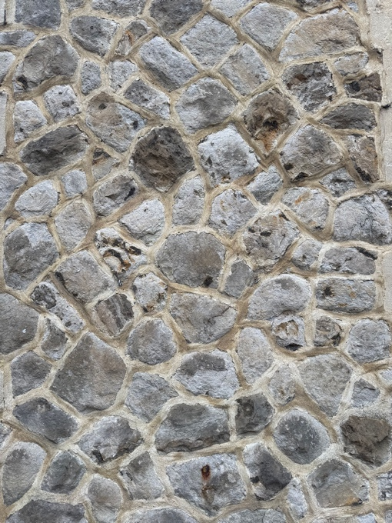
Figure 1. The wall of St.James Hatcham Building (photo by author).

Documentation
Raw Output
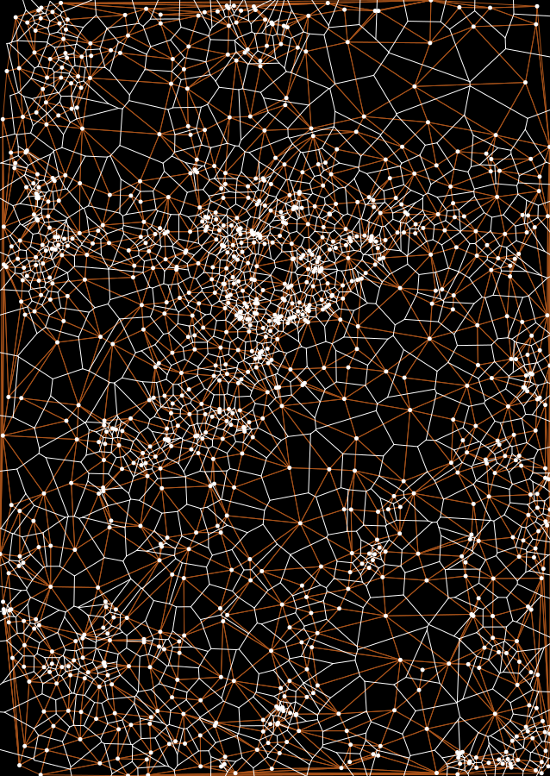
Figure 2. Exported image from python code (screen captured by author).

Final work
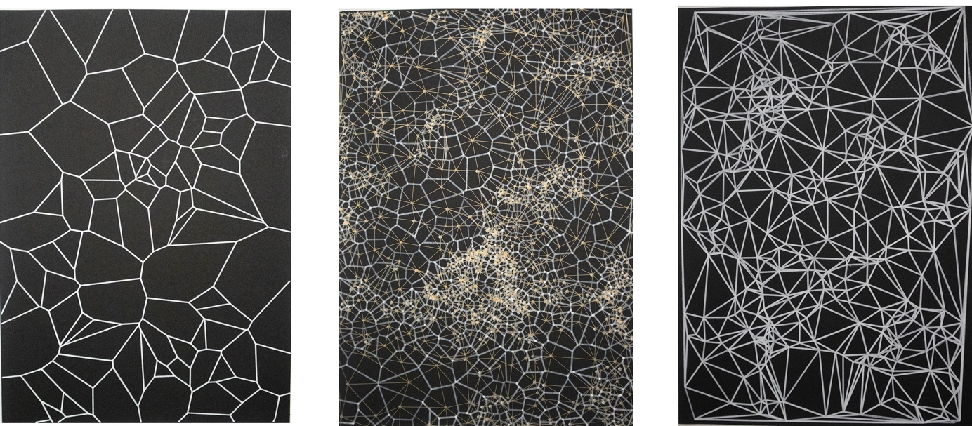
Figure 3. Combination of prints (edited by author).
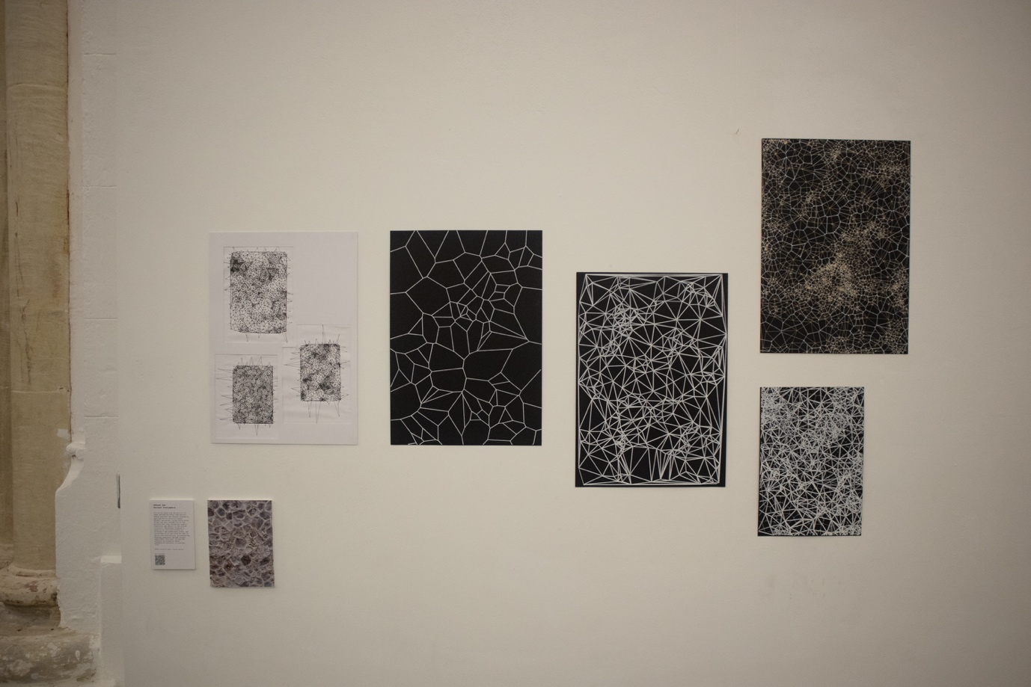
Figure 4. Installation (photo by author).

Process
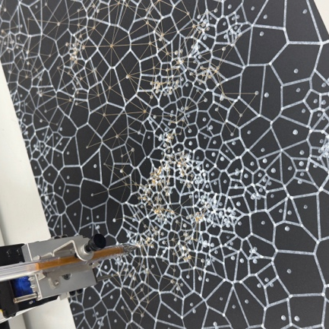 | 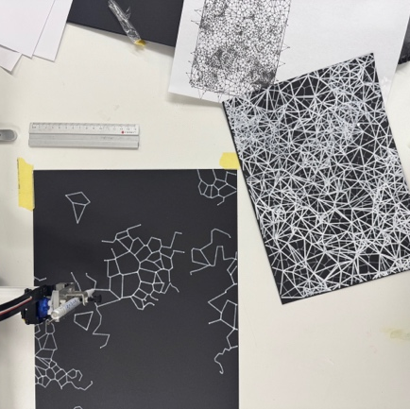 | 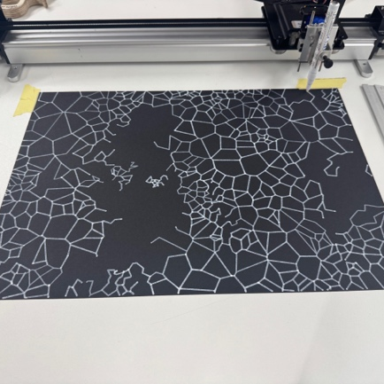
Figure 4. (photo by author). | Figure 5. (photo by author). | Figure 6. (photo by author).

Reflection

Process Analysis: Successes and Challenges
The initial iteration of ‘Voronoi Everywhere’ produced several positive outcomes, primarily in the successful integration of complex computational tools. The core technical achievement was the functional implementation of the Voronoi and Delaunay triangulation algorithms using the SciPy library. This proved efficient and highly flexible, allowing for robust parameter adjustment. Furthermore, integrating Perlin noise allowed the patterns to move beyond simple, geometric tessellation, successfully introducing the desired elements of organic complexity and scalability. The usage of brightness of the noise function provided granular control over the distribution of the generated cells, which was essential for mimicking natural wear and dynamic texture rather than evenly distributed grid lines.
However, the project also presented specific challenges. Firstly, while the core Python logic was effective, optimising the printing workflow with the AxiDraw plotting machine proved challenging, particularly when generating outputs for A3 paper. This demanding process, moving from rapid prototyping to a final output, limited the ability to test more diverse visualisations. Secondly, the artistic integration of the output remained tied to a purely digital and flat 2D print format. While the choice of a golden gel pen layered over a white marker created a pleasing perspective effect, this material constraint limited the realisation of the work’s spatial concept, particularly its connection to the architectural environment that inspired it. The current 2D presentation does not fully convey the sense of depth, expansion, and physical volume in the project’s conceptual basis.

Future Work and Iterations
The next iterations of ‘Voronoi Everywhere’ can be focused on material expansion, with the project’s defining goal being to transcend the 2D surface. Conceptually and materially, the future plan involves realising the generated patterns not merely as static prints but as a physical, site-specific installation. This would involve using pins and strings stretched across on top of the prints or even over the prints through the exhibition space, thus expanding the print into a physical presence and engaging actively with volume and light. By mapping the calculated Voronoi diagram and Delaunay Triangulations onto three-dimensional space, the work will physically expand beyond the A3 paper size, similar to one of the sketches (Figure 7). This approach would transform the abstract code into a immersive structure, allowing the audience to physically experience the "expansion" of the mathematical diagram into their environment.
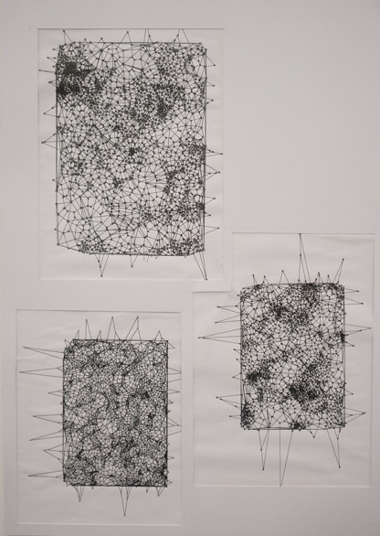
Figure 7. Sketch drawn by AxiDraw (photo by author).

References & Useful Links
Code Availability: The complete python source code for this project is publicly available via a GitHub repository (https://github.com/devsohyun/pfad-voronoi-exploration)
Aurenhammer, F., Klein, R. and Lee, D.-T. (2013). Voronoi Diagrams and Delaunay Triangulations. Singapore: World Scientific Publishing Co. Pte. Ltd.
DigitalSreeni (2022). 273 - What is Voronoi - explanation using python code. 8 June. Available at: https://www.youtube.com/watch?v=g5FnaNtcCzU (Accessed: 16 November 2025).
D3 (2025). Hover Voronoi / D3 | Observable. Available at: https://observablehq.com/@d3/hover-voronoi (Accessed: 18 November 2025).
Held, M., Mann, C. and de Spéville, B. (2011). The Geometric Stability of Voronoi Diagrams with respect to Small Changes of the Sites. arXiv e-prints. Available at: https://arxiv.org/pdf/1103.4125.pdf (Accessed: 18 November 2025).
SciPy developers (2025). scipy.spatial.Delaunay. Available at: https://docs.scipy.org/doc/scipy/reference/generated/scipy.spatial.Delaunay.html (Accessed: 17 November 2025).
SciPy developers (2025). scipy.spatial.Voronoi. Available at: https://docs.scipy.org/doc/scipy/reference/generated/scipy.spatial.Voronoi.html (Accessed: 18 November 2025).
Wikipedia contributors (2025). 1854 Broad Street cholera outbreak. Available at: https://en.wikipedia.org/wiki/1854_Broad_Street_cholera_outbreak (Accessed: 18 November 2025).

